武汉纺织大学

Web应用开发课程设计

**基于Servlet的产品查询系统**

**学 院： 数学与计算机学院**

**班 级： 物联网11803**

**姓 名： 余昌昊**

**学 号： 1804280303**

**指导老师： 聂刚**

**成 绩：**

**完成日期： 2020年12月15日**

目 录

1 需求分析 1

1.1主界面 1

1.2各项功能 1

1.2.1 高亮显示 3

1.2.2 模糊查询 1

1.2.3 清除条件 1

1.2.4 批量选择 2

1.2.5 分页显示 2

1.2.6 分页跳转 3

2 系统设计 3

2.1 ER图 4

2.2 UML类图（Class Diagram） 4

2.3 UML时序图（Sequence Diagram） 6

3 系统实现 9

3.1 项目结构 9

3.2 配置文件 9

3.2.1 web.xml文件 9

3.2.2 queryProduct文件 9

3.3 VO类Page.java 10

3.4 VO类Product.java 10

3.5 DAO类ProductDao.java 11

4 系统测试 14

5 系统总结 14

# 1 需求分析

设计一个产品查询系统，实现“模糊查询”、“清除条件”、“批量选择”、“分页显示”、“页面跳转”等功能，具体要求如下：

## 1.2主菜单

在网页栏中输入http://localhost:8080/webwork/bstable.html，进入系统主界面，如下：

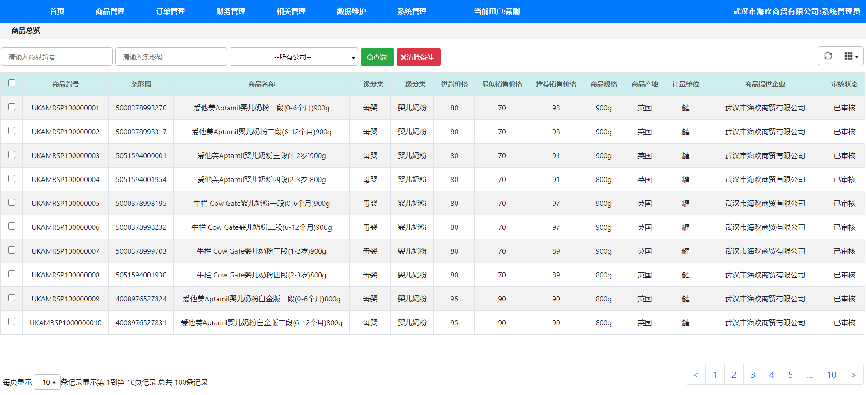

## 1.3各项功能

**1.2.1 高亮显示**

此处使用了BootStrap框架,首先使用了table-striped将表格中奇数行和偶数行内容使用不同的颜色区分,再就是table-bordered将表格中添加边框,还有table-hover实现鼠标移动到指定行后会发生背景颜色上的变化,最后是table-responsive使table的宽高随着文字内容的多少和大小自适应。

**1.2.2 模糊查询**

在商品货号输入框、条形码输入框、公司选择栏中输入信息,点击查询按钮会触发查询按钮的点击事件,调用controller中的queryProduct,并通过Ajax将查询到的数据返回到表格中,如果有符合模糊查询条件的产品,那么这些产品会出现在表格中,如果没有,则表格为空白。

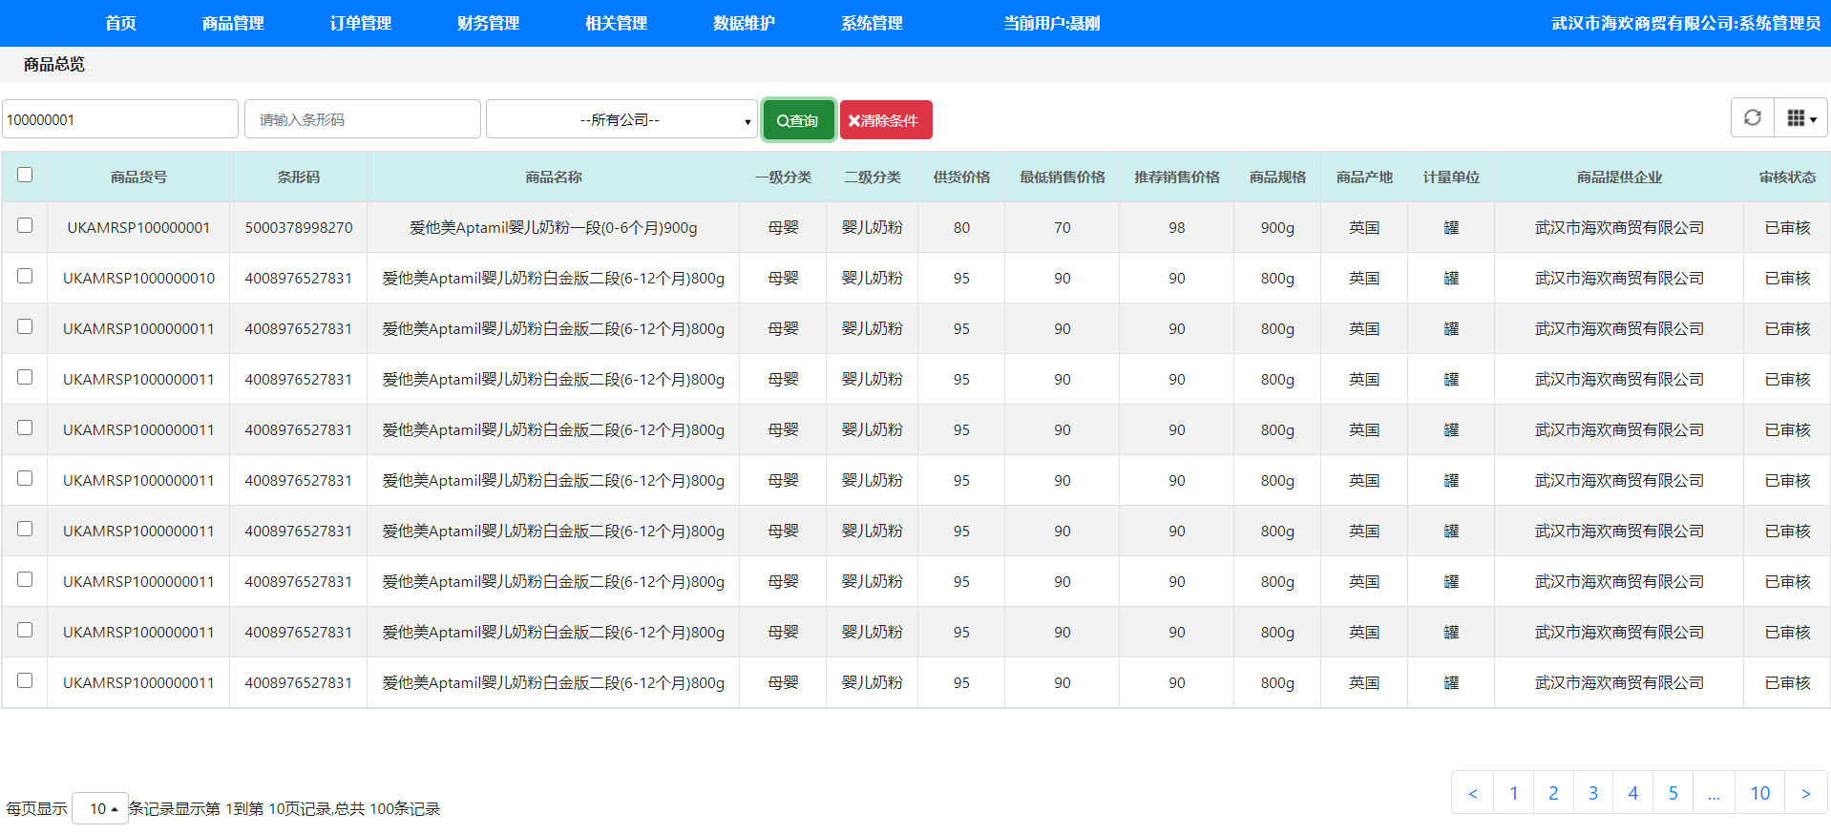

**1.2.3 清除条件**

点击清除条件按钮后会触发清除按钮的点击事件,当清楚条件按钮被点击后,通过Jquery获取两个输入框和一个选择框,并将它们的val修改为空白。

**1.2.4 批量选择**

表头中的checkbox会被设置一个点击事件,当表头中的checkbox被点击后,首先通过prop判断表头的checkbox是否已被点击,如果表头的checkbox已被点击,则将其下方所有除表头的checkbox设置为已被点击,否则,将它们设置为未被点击。

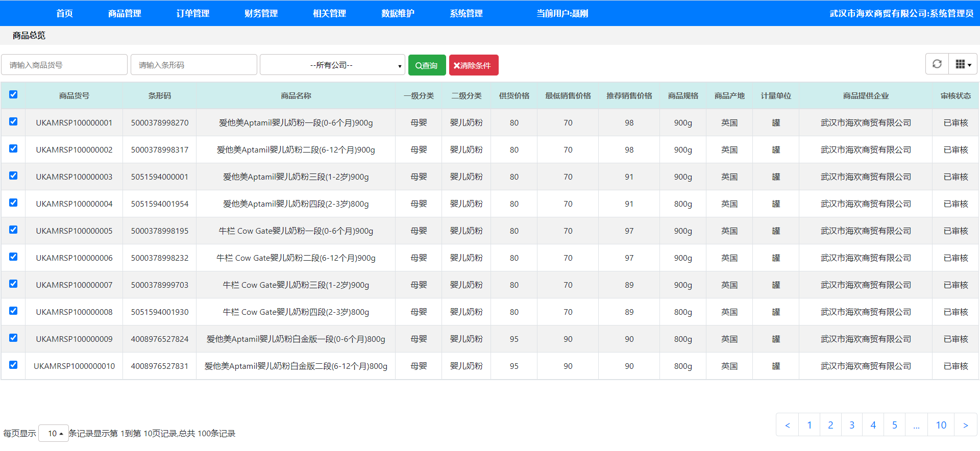

**1.2.5 分页显示**

在左下角的选择框中如果修改其中的数值,会触发其select中的change事件,当选择框被修改后,选择框会执行change函数,函数会调用一次Ajax,从而改变界面中条数的显示。

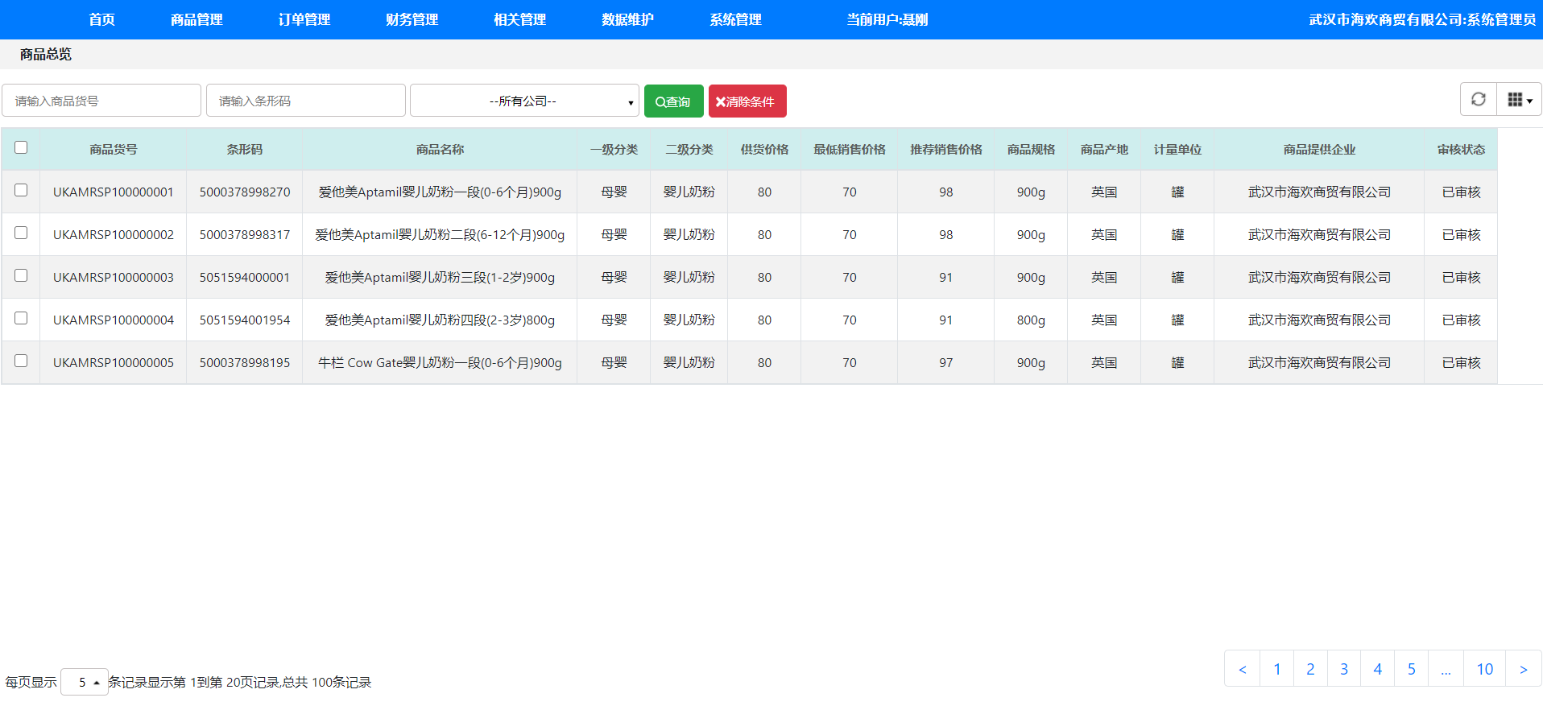

**1.2.6 分页跳转**

右下角一共有许多页面按钮,当按钮被点击后会触发点击事件,当其中一个按钮被点击后,给它添加active类实现高亮,当其他按钮被点击后，将其他按钮高亮去除再添加自己的高亮,实现只给被点击按钮添加高亮,当按钮被点击的同时也会将按钮中的数字和页面中的数据作为Ajax的参数传递过去最后实现分页跳转。

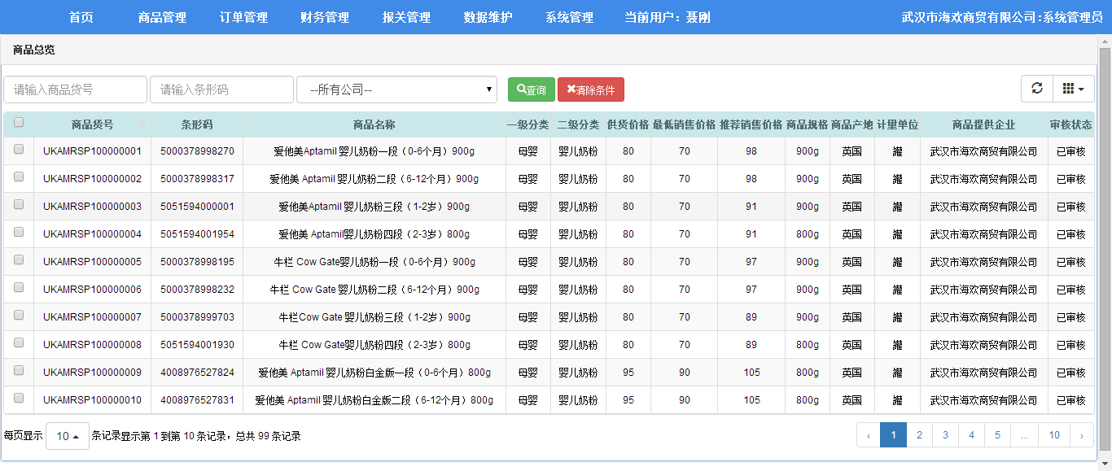

# **2 系统设计**

## 2.1 ER图

数据库设计表，对应的ER图如图所示。

%3CmxGraphModel%3E%3Croot%3E%3CmxCell%20id%3D%220%22%2F%3E%3CmxCell%20id%3D%221%22%20parent%3D%220%22%2F%3E%3Cmysql.table%20entity.table.tableName%3D%22uses%22%20label%3D%22uses%22%20id%3D%222%22%3E%3CmxCell%20style%3D%22swimlane%3BfontStyle%3D0%3BchildLayout%3DstackLayout%3Bhorizontal%3D1%3Bhtml%3D1%3BstartSize%3D26%3BfillColor%3D%23b0e3e6%3BhorizontalStack%3D0%3BresizeParent%3D1%3BresizeParentMax%3D0%3BresizeLast%3D0%3Bcollapsible%3D1%3BmarginBottom%3D0%3BswimlaneFillColor%3D%23ffffff%3Balign%3Dcenter%3BfontSize%3D13%3BstrokeColor%3D%230e8088%3Brounded%3D0%3Bshadow%3D1%3Bcomic%3D0%3Bglass%3D0%3BgradientDirection%3Dsouth%3BgradientColor%3D%23ffffff%3B%22%20vertex%3D%221%22%20connectable%3D%220%22%20parent%3D%221%22%3E%3CmxGeometry%20x%3D%2260%22%20y%3D%2250%22%20width%3D%22310%22%20height%3D%22130%22%20as%3D%22geometry%22%2F%3E%3C%2FmxCell%3E%3C%2Fmysql.table%3E%3Cmysql.column%20entity.column.tableName%3D%22uses%22%20entity.column.name%3D%22userName%22%20entity.column.dataType%3D%22VARCHAR%22%20entity.column.PK%3D%22true%22%20label%3D%22%26lt%3Bimg%20title%3D%26quot%3BPrimary%20Key%26quot%3B%20src%3D%26quot%3Bimg%2Fdb%2Fkey1.png%26quot%3B%20width%3D%26quot%3B16%26quot%3B%20height%3D%26quot%3B16%26quot%3B%20align%3D%26quot%3Btop%26quot%3B%26gt%3B%26amp%3Bnbsp%3B%26lt%3Bfont%20size%3D%26quot%3B1%26quot%3B%20face%3D%26quot%3BTahoma%26quot%3B%26gt%3B%26lt%3Bspan%20style%3D%26quot%3Bfont-size%3A%2013px%26quot%3B%26gt%3B%26lt%3Bb%26gt%3Bid%20int%20primary%20key%26lt%3B%2Fb%26gt%3B%26lt%3B%2Fspan%26gt%3B%26lt%3B%2Ffont%26gt%3B%22%20entity.column.oldName%3D%22id%22%20entity.column.datalen%3D%2220%22%20entity.column.decimals%3D%22%22%20entity.column.autoIncreament%3D%22%22%20entity.column.unsigned%3D%22%22%20entity.column.bin%3D%22%22%20entity.column.ascii%3D%22%22%20entity.column.unicode%3D%22%22%20entity.column.unique%3D%22%22%20entity.column.isNotNull%3D%22NOT%20NULL%22%20entity.column.defaultValue%3D%22%22%20entity.column.comment%3D%22%22%20entity.column.enum%3D%22%22%20entity.column.set%3D%22%22%20entity.column.enumSetValue%3D%22%22%20id%3D%223%22%3E%3CmxCell%20style%3D%22text%3Bhtml%3D1%3BstrokeColor%3Dnone%3BfillColor%3Dnone%3BspacingLeft%3D4%3BspacingRight%3D4%3Boverflow%3Dhidden%3Brotatable%3D0%3BportConstraint%3Deastwest%3BfontSize%3D12%3BverticalAlign%3Dmiddle%3B%22%20vertex%3D%221%22%20parent%3D%222%22%3E%3CmxGeometry%20y%3D%2226%22%20width%3D%22310%22%20height%3D%2226%22%20as%3D%22geometry%22%2F%3E%3C%2FmxCell%3E%3C%2Fmysql.column%3E%3Cmysql.column%20entity.column.tableName%3D%22uses%22%20entity.column.name%3D%22chrName%22%20entity.column.datalen%3D%2220%22%20entity.column.dataType%3D%22VARCHAR%22%20label%3D%22%26lt%3Bimg%20title%3D%26quot%3BPrimary%20Key%26quot%3B%20src%3D%26quot%3Bimages%2Fspacer.gif%26quot%3B%20width%3D%26quot%3B16%26quot%3B%20height%3D%26quot%3B16%26quot%3B%20align%3D%26quot%3Btop%26quot%3B%26gt%3B%26amp%3Bnbsp%3B%26lt%3Bfont%20size%3D%26quot%3B1%26quot%3B%20face%3D%26quot%3BTahoma%26quot%3B%26gt%3B%26lt%3Bspan%20style%3D%26quot%3Bfont-size%3A%2013px%26quot%3B%26gt%3B%26lt%3Bb%26gt%3Bname%20varchar(10)%26lt%3B%2Fb%26gt%3B%26lt%3B%2Fspan%26gt%3B%26lt%3B%2Ffont%26gt%3B%22%20entity.column.oldName%3D%22name%22%20entity.column.decimals%3D%22%22%20entity.column.autoIncreament%3D%22%22%20entity.column.unsigned%3D%22%22%20entity.column.bin%3D%22%22%20entity.column.ascii%3D%22%22%20entity.column.unicode%3D%22%22%20entity.column.PK%3D%22false%22%20entity.column.unique%3D%22%22%20entity.column.isNotNull%3D%22%22%20entity.column.defaultValue%3D%22%22%20entity.column.comment%3D%22%22%20entity.column.enum%3D%22%22%20entity.column.set%3D%22%22%20entity.column.enumSetValue%3D%22%22%20id%3D%224%22%3E%3CmxCell%20style%3D%22text%3Bhtml%3D1%3BstrokeColor%3Dnone%3BfillColor%3Dnone%3BspacingLeft%3D4%3BspacingRight%3D4%3Boverflow%3Dhidden%3Brotatable%3D0%3BportConstraint%3Deastwest%3BfontSize%3D12%3BverticalAlign%3Dmiddle%3B%22%20vertex%3D%221%22%20parent%3D%222%22%3E%3CmxGeometry%20y%3D%2252%22%20width%3D%22310%22%20height%3D%2226%22%20as%3D%22geometry%22%2F%3E%3C%2FmxCell%3E%3C%2Fmysql.column%3E%3Cmysql.column%20entity.column.tableName%3D%22uses%22%20entity.column.name%3D%22password%22%20entity.column.datalen%3D%2250%22%20entity.column.dataType%3D%22VARCHAR%22%20label%3D%22%26lt%3Bimg%20title%3D%26quot%3BPrimary%20Key%26quot%3B%20src%3D%26quot%3Bimages%2Fspacer.gif%26quot%3B%20width%3D%26quot%3B16%26quot%3B%20height%3D%26quot%3B16%26quot%3B%20align%3D%26quot%3Btop%26quot%3B%26gt%3B%26amp%3Bnbsp%3B%26lt%3Bfont%20size%3D%26quot%3B1%26quot%3B%20face%3D%26quot%3BTahoma%26quot%3B%26gt%3B%26lt%3Bspan%20style%3D%26quot%3Bfont-size%3A%2013px%26quot%3B%26gt%3B%26lt%3Bb%26gt%3Bname%20varchar(10)%26lt%3B%2Fb%26gt%3B%26lt%3B%2Fspan%26gt%3B%26lt%3B%2Ffont%26gt%3B%22%20entity.column.oldName%3D%22chrName%22%20entity.column.decimals%3D%22%22%20entity.column.autoIncreament%3D%22%22%20entity.column.unsigned%3D%22%22%20entity.column.bin%3D%22%22%20entity.column.ascii%3D%22%22%20entity.column.unicode%3D%22%22%20entity.column.PK%3D%22false%22%20entity.column.unique%3D%22%22%20entity.column.isNotNull%3D%22%22%20entity.column.defaultValue%3D%22%22%20entity.column.comment%3D%22%E5%AF%86%E7%A0%81%22%20entity.column.enum%3D%22%22%20entity.column.set%3D%22%22%20entity.column.enumSetValue%3D%22%22%20id%3D%225%22%3E%3CmxCell%20style%3D%22text%3Bhtml%3D1%3BstrokeColor%3Dnone%3BfillColor%3Dnone%3BspacingLeft%3D4%3BspacingRight%3D4%3Boverflow%3Dhidden%3Brotatable%3D0%3BportConstraint%3Deastwest%3BfontSize%3D12%3BverticalAlign%3Dmiddle%3B%22%20vertex%3D%221%22%20parent%3D%222%22%3E%3CmxGeometry%20y%3D%2278%22%20width%3D%22310%22%20height%3D%2226%22%20as%3D%22geometry%22%2F%3E%3C%2FmxCell%3E%3C%2Fmysql.column%3E%3Cmysql.column%20entity.column.tableName%3D%22uses%22%20entity.column.name%3D%22role%22%20entity.column.datalen%3D%2220%22%20entity.column.dataType%3D%22VARCHAR%22%20label%3D%22%26lt%3Bimg%20title%3D%26quot%3BPrimary%20Key%26quot%3B%20src%3D%26quot%3Bimages%2Fspacer.gif%26quot%3B%20width%3D%26quot%3B16%26quot%3B%20height%3D%26quot%3B16%26quot%3B%20align%3D%26quot%3Btop%26quot%3B%26gt%3B%26amp%3Bnbsp%3B%26lt%3Bfont%20size%3D%26quot%3B1%26quot%3B%20face%3D%26quot%3BTahoma%26quot%3B%26gt%3B%26lt%3Bspan%20style%3D%26quot%3Bfont-size%3A%2013px%26quot%3B%26gt%3B%26lt%3Bb%26gt%3Bname%20varchar(10)%26lt%3B%2Fb%26gt%3B%26lt%3B%2Fspan%26gt%3B%26lt%3B%2Ffont%26gt%3B%22%20entity.column.oldName%3D%22chrName%22%20entity.column.decimals%3D%22%22%20entity.column.autoIncreament%3D%22%22%20entity.column.unsigned%3D%22%22%20entity.column.bin%3D%22%22%20entity.column.ascii%3D%22%22%20entity.column.unicode%3D%22%22%20entity.column.PK%3D%22false%22%20entity.column.unique%3D%22%22%20entity.column.isNotNull%3D%22%22%20entity.column.defaultValue%3D%22%22%20entity.column.comment%3D%22%E8%A7%92%E8%89%B2%22%20entity.column.enum%3D%22%22%20entity.column.set%3D%22%22%20entity.column.enumSetValue%3D%22%22%20id%3D%226%22%3E%3CmxCell%20style%3D%22text%3Bhtml%3D1%3BstrokeColor%3Dnone%3BfillColor%3Dnone%3BspacingLeft%3D4%3BspacingRight%3D4%3Boverflow%3Dhidden%3Brotatable%3D0%3BportConstraint%3Deastwest%3BfontSize%3D12%3BverticalAlign%3Dmiddle%3B%22%20vertex%3D%221%22%20parent%3D%222%22%3E%3CmxGeometry%20y%3D%22104%22%20width%3D%22310%22%20height%3D%2226%22%20as%3D%22geometry%22%2F%3E%3C%2FmxCell%3E%3C%2Fmysql.column%3E%3Cmysql.table%20entity.table.tableName%3D%22product%22%20label%3D%22product%22%20id%3D%227%22%3E%3CmxCell%20style%3D%22swimlane%3BfontStyle%3D0%3BchildLayout%3DstackLayout%3Bhorizontal%3D1%3Bhtml%3D1%3BstartSize%3D26%3BfillColor%3D%23b0e3e6%3BhorizontalStack%3D0%3BresizeParent%3D1%3BresizeParentMax%3D0%3BresizeLast%3D0%3Bcollapsible%3D1%3BmarginBottom%3D0%3BswimlaneFillColor%3D%23ffffff%3Balign%3Dcenter%3BfontSize%3D13%3BstrokeColor%3D%230e8088%3Brounded%3D0%3Bshadow%3D1%3Bcomic%3D0%3Bglass%3D0%3BgradientDirection%3Dsouth%3BgradientColor%3D%23ffffff%3B%22%20vertex%3D%221%22%20connectable%3D%220%22%20parent%3D%221%22%3E%3CmxGeometry%20x%3D%2260%22%20y%3D%22210%22%20width%3D%22310%22%20height%3D%22130%22%20as%3D%22geometry%22%2F%3E%3C%2FmxCell%3E%3C%2Fmysql.table%3E%3Cmysql.column%20entity.column.tableName%3D%22product%22%20entity.column.name%3D%22barcode%22%20entity.column.dataType%3D%22VARCHAR%22%20entity.column.PK%3D%22true%22%20label%3D%22%26lt%3Bimg%20title%3D%26quot%3BPrimary%20Key%26quot%3B%20src%3D%26quot%3Bimg%2Fdb%2Fkey1.png%26quot%3B%20width%3D%26quot%3B16%26quot%3B%20height%3D%26quot%3B16%26quot%3B%20align%3D%26quot%3Btop%26quot%3B%26gt%3B%26amp%3Bnbsp%3B%26lt%3Bfont%20size%3D%26quot%3B1%26quot%3B%20face%3D%26quot%3BTahoma%26quot%3B%26gt%3B%26lt%3Bspan%20style%3D%26quot%3Bfont-size%3A%2013px%26quot%3B%26gt%3B%26lt%3Bb%26gt%3Bid%20int%20primary%20key%26lt%3B%2Fb%26gt%3B%26lt%3B%2Fspan%26gt%3B%26lt%3B%2Ffont%26gt%3B%22%20entity.column.oldName%3D%22id%22%20entity.column.datalen%3D%2210%22%20entity.column.decimals%3D%22%22%20entity.column.autoIncreament%3D%22%22%20entity.column.unsigned%3D%22%22%20entity.column.bin%3D%22%22%20entity.column.ascii%3D%22%22%20entity.column.unicode%3D%22%22%20entity.column.unique%3D%22%22%20entity.column.isNotNull%3D%22NOT%20NULL%22%20entity.column.defaultValue%3D%22%22%20entity.column.comment%3D%22%22%20entity.column.enum%3D%22%22%20entity.column.set%3D%22%22%20entity.column.enumSetValue%3D%22%22%20id%3D%228%22%3E%3CmxCell%20style%3D%22text%3Bhtml%3D1%3BstrokeColor%3Dnone%3BfillColor%3Dnone%3BspacingLeft%3D4%3BspacingRight%3D4%3Boverflow%3Dhidden%3Brotatable%3D0%3BportConstraint%3Deastwest%3BfontSize%3D12%3BverticalAlign%3Dmiddle%3B%22%20vertex%3D%221%22%20parent%3D%227%22%3E%3CmxGeometry%20y%3D%2226%22%20width%3D%22310%22%20height%3D%2226%22%20as%3D%22geometry%22%2F%3E%3C%2FmxCell%3E%3C%2Fmysql.column%3E%3Cmysql.column%20entity.column.tableName%3D%22product%22%20entity.column.name%3D%22productName%22%20entity.column.datalen%3D%2250%22%20entity.column.dataType%3D%22VARCHAR%22%20label%3D%22%26lt%3Bimg%20title%3D%26quot%3BPrimary%20Key%26quot%3B%20src%3D%26quot%3Bimages%2Fspacer.gif%26quot%3B%20width%3D%26quot%3B16%26quot%3B%20height%3D%26quot%3B16%26quot%3B%20align%3D%26quot%3Btop%26quot%3B%26gt%3B%26amp%3Bnbsp%3B%26lt%3Bfont%20size%3D%26quot%3B1%26quot%3B%20face%3D%26quot%3BTahoma%26quot%3B%26gt%3B%26lt%3Bspan%20style%3D%26quot%3Bfont-size%3A%2013px%26quot%3B%26gt%3B%26lt%3Bb%26gt%3Bname%20varchar(10)%26lt%3B%2Fb%26gt%3B%26lt%3B%2Fspan%26gt%3B%26lt%3B%2Ffont%26gt%3B%22%20entity.column.oldName%3D%22name%22%20entity.column.decimals%3D%22%22%20entity.column.autoIncreament%3D%22%22%20entity.column.unsigned%3D%22%22%20entity.column.bin%3D%22%22%20entity.column.ascii%3D%22%22%20entity.column.unicode%3D%22%22%20entity.column.PK%3D%22false%22%20entity.column.unique%3D%22%22%20entity.column.isNotNull%3D%22%22%20entity.column.defaultValue%3D%22%22%20entity.column.comment%3D%22%22%20entity.column.enum%3D%22%22%20entity.column.set%3D%22%22%20entity.column.enumSetValue%3D%22%22%20id%3D%229%22%3E%3CmxCell%20style%3D%22text%3Bhtml%3D1%3BstrokeColor%3Dnone%3BfillColor%3Dnone%3BspacingLeft%3D4%3BspacingRight%3D4%3Boverflow%3Dhidden%3Brotatable%3D0%3BportConstraint%3Deastwest%3BfontSize%3D12%3BverticalAlign%3Dmiddle%3B%22%20vertex%3D%221%22%20parent%3D%227%22%3E%3CmxGeometry%20y%3D%2252%22%20width%3D%22310%22%20height%3D%2226%22%20as%3D%22geometry%22%2F%3E%3C%2FmxCell%3E%3C%2Fmysql.column%3E%3Cmysql.column%20entity.column.tableName%3D%22product%22%20entity.column.name%3D%22price%22%20entity.column.datalen%3D%229%22%20entity.column.dataType%3D%22DECIMAL%22%20label%3D%22%26lt%3Bimg%20title%3D%26quot%3BPrimary%20Key%26quot%3B%20src%3D%26quot%3Bimages%2Fspacer.gif%26quot%3B%20width%3D%26quot%3B16%26quot%3B%20height%3D%26quot%3B16%26quot%3B%20align%3D%26quot%3Btop%26quot%3B%26gt%3B%26amp%3Bnbsp%3B%26lt%3Bfont%20size%3D%26quot%3B1%26quot%3B%20face%3D%26quot%3BTahoma%26quot%3B%26gt%3B%26lt%3Bspan%20style%3D%26quot%3Bfont-size%3A%2013px%26quot%3B%26gt%3B%26lt%3Bb%26gt%3Bname%20varchar(10)%26lt%3B%2Fb%26gt%3B%26lt%3B%2Fspan%26gt%3B%26lt%3B%2Ffont%26gt%3B%22%20entity.column.oldName%3D%22price%22%20entity.column.decimals%3D%222%22%20entity.column.autoIncreament%3D%22%22%20entity.column.unsigned%3D%22%22%20entity.column.bin%3D%22%22%20entity.column.ascii%3D%22%22%20entity.column.unicode%3D%22%22%20entity.column.PK%3D%22false%22%20entity.column.unique%3D%22%22%20entity.column.isNotNull%3D%22%22%20entity.column.defaultValue%3D%22%22%20entity.column.comment%3D%22%22%20entity.column.enum%3D%22%22%20entity.column.set%3D%22%22%20entity.column.enumSetValue%3D%22%22%20id%3D%2210%22%3E%3CmxCell%20style%3D%22text%3Bhtml%3D1%3BstrokeColor%3Dnone%3BfillColor%3Dnone%3BspacingLeft%3D4%3BspacingRight%3D4%3Boverflow%3Dhidden%3Brotatable%3D0%3BportConstraint%3Deastwest%3BfontSize%3D12%3BverticalAlign%3Dmiddle%3B%22%20vertex%3D%221%22%20parent%3D%227%22%3E%3CmxGeometry%20y%3D%2278%22%20width%3D%22310%22%20height%3D%2226%22%20as%3D%22geometry%22%2F%3E%3C%2FmxCell%3E%3C%2Fmysql.column%3E%3Cmysql.column%20entity.column.tableName%3D%22product%22%20entity.column.name%3D%22supply%22%20entity.column.datalen%3D%2220%22%20entity.column.dataType%3D%22VARCHAR%22%20label%3D%22%26lt%3Bimg%20title%3D%26quot%3BPrimary%20Key%26quot%3B%20src%3D%26quot%3Bimages%2Fspacer.gif%26quot%3B%20width%3D%26quot%3B16%26quot%3B%20height%3D%26quot%3B16%26quot%3B%20align%3D%26quot%3Btop%26quot%3B%26gt%3B%26amp%3Bnbsp%3B%26lt%3Bfont%20size%3D%26quot%3B1%26quot%3B%20face%3D%26quot%3BTahoma%26quot%3B%26gt%3B%26lt%3Bspan%20style%3D%26quot%3Bfont-size%3A%2013px%26quot%3B%26gt%3B%26lt%3Bb%26gt%3Bname%20varchar(10)%26lt%3B%2Fb%26gt%3B%26lt%3B%2Fspan%26gt%3B%26lt%3B%2Ffont%26gt%3B%22%20entity.column.oldName%3D%22price%22%20entity.column.decimals%3D%22%22%20entity.column.autoIncreament%3D%22%22%20entity.column.unsigned%3D%22%22%20entity.column.bin%3D%22%22%20entity.column.ascii%3D%22%22%20entity.column.unicode%3D%22%22%20entity.column.PK%3D%22false%22%20entity.column.unique%3D%22%22%20entity.column.isNotNull%3D%22%22%20entity.column.defaultValue%3D%22%22%20entity.column.comment%3D%22%22%20entity.column.enum%3D%22%22%20entity.column.set%3D%22%22%20entity.column.enumSetValue%3D%22%22%20id%3D%2211%22%3E%3CmxCell%20style%3D%22text%3Bhtml%3D1%3BstrokeColor%3Dnone%3BfillColor%3Dnone%3BspacingLeft%3D4%3BspacingRight%3D4%3Boverflow%3Dhidden%3Brotatable%3D0%3BportConstraint%3Deastwest%3BfontSize%3D12%3BverticalAlign%3Dmiddle%3B%22%20vertex%3D%221%22%20parent%3D%227%22%3E%3CmxGeometry%20y%3D%22104%22%20width%3D%22310%22%20height%3D%2226%22%20as%3D%22geometry%22%2F%3E%3C%2FmxCell%3E%3C%2Fmysql.column%3E%3Cmysql.table%20entity.table.tableName%3D%22saleDetail%22%20label%3D%22saleDetail%22%20id%3D%2212%22%3E%3CmxCell%20style%3D%22swimlane%3BfontStyle%3D0%3BchildLayout%3DstackLayout%3Bhorizontal%3D1%3Bhtml%3D1%3BstartSize%3D26%3BfillColor%3D%23b0e3e6%3BhorizontalStack%3D0%3BresizeParent%3D1%3BresizeParentMax%3D0%3BresizeLast%3D0%3Bcollapsible%3D1%3BmarginBottom%3D0%3BswimlaneFillColor%3D%23ffffff%3Balign%3Dcenter%3BfontSize%3D13%3BstrokeColor%3D%230e8088%3Brounded%3D0%3Bshadow%3D1%3Bcomic%3D0%3Bglass%3D0%3BgradientDirection%3Dsouth%3BgradientColor%3D%23ffffff%3B%22%20vertex%3D%221%22%20connectable%3D%220%22%20parent%3D%221%22%3E%3CmxGeometry%20x%3D%22480%22%20y%3D%2280%22%20width%3D%22280%22%20height%3D%22208%22%20as%3D%22geometry%22%2F%3E%3C%2FmxCell%3E%3C%2Fmysql.table%3E%3Cmysql.column%20entity.column.tableName%3D%22saleDetail%22%20entity.column.name%3D%22lsh%22%20entity.column.dataType%3D%22VARCHAR%22%20entity.column.PK%3D%22true%22%20label%3D%22%26lt%3Bimg%20title%3D%26quot%3BPrimary%20Key%26quot%3B%20src%3D%26quot%3Bimg%2Fdb%2Fkey1.png%26quot%3B%20width%3D%26quot%3B16%26quot%3B%20height%3D%26quot%3B16%26quot%3B%20align%3D%26quot%3Btop%26quot%3B%26gt%3B%26amp%3Bnbsp%3B%26lt%3Bfont%20size%3D%26quot%3B1%26quot%3B%20face%3D%26quot%3BTahoma%26quot%3B%26gt%3B%26lt%3Bspan%20style%3D%26quot%3Bfont-size%3A%2013px%26quot%3B%26gt%3B%26lt%3Bb%26gt%3Bid%20int%20primary%20key%26lt%3B%2Fb%26gt%3B%26lt%3B%2Fspan%26gt%3B%26lt%3B%2Ffont%26gt%3B%22%20entity.column.oldName%3D%22id%22%20entity.column.datalen%3D%2220%22%20entity.column.decimals%3D%22%22%20entity.column.autoIncreament%3D%22%22%20entity.column.unsigned%3D%22%22%20entity.column.bin%3D%22%22%20entity.column.ascii%3D%22%22%20entity.column.unicode%3D%22%22%20entity.column.unique%3D%22%22%20entity.column.isNotNull%3D%22NOT%20NULL%22%20entity.column.defaultValue%3D%22%22%20entity.column.comment%3D%22%22%20entity.column.enum%3D%22%22%20entity.column.set%3D%22%22%20entity.column.enumSetValue%3D%22%22%20id%3D%2213%22%3E%3CmxCell%20style%3D%22text%3Bhtml%3D1%3BstrokeColor%3Dnone%3BfillColor%3Dnone%3BspacingLeft%3D4%3BspacingRight%3D4%3Boverflow%3Dhidden%3Brotatable%3D0%3BportConstraint%3Deastwest%3BfontSize%3D12%3BverticalAlign%3Dmiddle%3B%22%20vertex%3D%221%22%20parent%3D%2212%22%3E%3CmxGeometry%20y%3D%2226%22%20width%3D%22280%22%20height%3D%2226%22%20as%3D%22geometry%22%2F%3E%3C%2FmxCell%3E%3C%2Fmysql.column%3E%3Cmysql.column%20entity.column.tableName%3D%22saleDetail%22%20entity.column.name%3D%22barcode%22%20entity.column.datalen%3D%2210%22%20entity.column.dataType%3D%22VARCHAR%22%20label%3D%22%26lt%3Bimg%20title%3D%26quot%3BPrimary%20Key%26quot%3B%20src%3D%26quot%3Bimages%2Fspacer.gif%26quot%3B%20width%3D%26quot%3B16%26quot%3B%20height%3D%26quot%3B16%26quot%3B%20align%3D%26quot%3Btop%26quot%3B%26gt%3B%26amp%3Bnbsp%3B%26lt%3Bfont%20size%3D%26quot%3B1%26quot%3B%20face%3D%26quot%3BTahoma%26quot%3B%26gt%3B%26lt%3Bspan%20style%3D%26quot%3Bfont-size%3A%2013px%26quot%3B%26gt%3B%26lt%3Bb%26gt%3Bname%20varchar(10)%26lt%3B%2Fb%26gt%3B%26lt%3B%2Fspan%26gt%3B%26lt%3B%2Ffont%26gt%3B%22%20entity.column.oldName%3D%22barcode%22%20entity.column.decimals%3D%22%22%20entity.column.autoIncreament%3D%22%22%20entity.column.unsigned%3D%22%22%20entity.column.bin%3D%22%22%20entity.column.ascii%3D%22%22%20entity.column.unicode%3D%22%22%20entity.column.PK%3D%22false%22%20entity.column.unique%3D%22%22%20entity.column.isNotNull%3D%22%22%20entity.column.defaultValue%3D%22%22%20entity.column.comment%3D%22%22%20entity.column.enum%3D%22%22%20entity.column.set%3D%22%22%20entity.column.enumSetValue%3D%22%22%20id%3D%2214%22%3E%3CmxCell%20style%3D%22text%3Bhtml%3D1%3BstrokeColor%3Dnone%3BfillColor%3Dnone%3BspacingLeft%3D4%3BspacingRight%3D4%3Boverflow%3Dhidden%3Brotatable%3D0%3BportConstraint%3Deastwest%3BfontSize%3D12%3BverticalAlign%3Dmiddle%3B%22%20vertex%3D%221%22%20parent%3D%2212%22%3E%3CmxGeometry%20y%3D%2252%22%20width%3D%22280%22%20height%3D%2226%22%20as%3D%22geometry%22%2F%3E%3C%2FmxCell%3E%3C%2Fmysql.column%3E%3Cmysql.column%20entity.column.tableName%3D%22saleDetail%22%20entity.column.name%3D%22productName%22%20entity.column.datalen%3D%2250%22%20entity.column.dataType%3D%22VARCHAR%22%20label%3D%22%26lt%3Bimg%20title%3D%26quot%3BPrimary%20Key%26quot%3B%20src%3D%26quot%3Bimages%2Fspacer.gif%26quot%3B%20width%3D%26quot%3B16%26quot%3B%20height%3D%26quot%3B16%26quot%3B%20align%3D%26quot%3Btop%26quot%3B%26gt%3B%26amp%3Bnbsp%3B%26lt%3Bfont%20size%3D%26quot%3B1%26quot%3B%20face%3D%26quot%3BTahoma%26quot%3B%26gt%3B%26lt%3Bspan%20style%3D%26quot%3Bfont-size%3A%2013px%26quot%3B%26gt%3B%26lt%3Bb%26gt%3Bname%20varchar(10)%26lt%3B%2Fb%26gt%3B%26lt%3B%2Fspan%26gt%3B%26lt%3B%2Ffont%26gt%3B%22%20entity.column.oldName%3D%22productName%22%20entity.column.decimals%3D%22%22%20entity.column.autoIncreament%3D%22%22%20entity.column.unsigned%3D%22%22%20entity.column.bin%3D%22%22%20entity.column.ascii%3D%22%22%20entity.column.unicode%3D%22%22%20entity.column.PK%3D%22false%22%20entity.column.unique%3D%22%22%20entity.column.isNotNull%3D%22%22%20entity.column.defaultValue%3D%22%22%20entity.column.comment%3D%22%22%20entity.column.enum%3D%22%22%20entity.column.set%3D%22%22%20entity.column.enumSetValue%3D%22%22%20id%3D%2215%22%3E%3CmxCell%20style%3D%22text%3Bhtml%3D1%3BstrokeColor%3Dnone%3BfillColor%3Dnone%3BspacingLeft%3D4%3BspacingRight%3D4%3Boverflow%3Dhidden%3Brotatable%3D0%3BportConstraint%3Deastwest%3BfontSize%3D12%3BverticalAlign%3Dmiddle%3B%22%20vertex%3D%221%22%20parent%3D%2212%22%3E%3CmxGeometry%20y%3D%2278%22%20width%3D%22280%22%20height%3D%2226%22%20as%3D%22geometry%22%2F%3E%3C%2FmxCell%3E%3C%2Fmysql.column%3E%3Cmysql.column%20entity.column.tableName%3D%22saleDetail%22%20entity.column.name%3D%22price%22%20entity.column.datalen%3D%229%22%20entity.column.dataType%3D%22DECIMAL%22%20label%3D%22%26lt%3Bimg%20title%3D%26quot%3BPrimary%20Key%26quot%3B%20src%3D%26quot%3Bimages%2Fspacer.gif%26quot%3B%20width%3D%26quot%3B16%26quot%3B%20height%3D%26quot%3B16%26quot%3B%20align%3D%26quot%3Btop%26quot%3B%26gt%3B%26amp%3Bnbsp%3B%26lt%3Bfont%20size%3D%26quot%3B1%26quot%3B%20face%3D%26quot%3BTahoma%26quot%3B%26gt%3B%26lt%3Bspan%20style%3D%26quot%3Bfont-size%3A%2013px%26quot%3B%26gt%3B%26lt%3Bb%26gt%3Bname%20varchar(10)%26lt%3B%2Fb%26gt%3B%26lt%3B%2Fspan%26gt%3B%26lt%3B%2Ffont%26gt%3B%22%20entity.column.oldName%3D%22productName%22%20entity.column.decimals%3D%222%22%20entity.column.autoIncreament%3D%22%22%20entity.column.unsigned%3D%22%22%20entity.column.bin%3D%22%22%20entity.column.ascii%3D%22%22%20entity.column.unicode%3D%22%22%20entity.column.PK%3D%22false%22%20entity.column.unique%3D%22%22%20entity.column.isNotNull%3D%22%22%20entity.column.defaultValue%3D%22%22%20entity.column.comment%3D%22%22%20entity.column.enum%3D%22%22%20entity.column.set%3D%22%22%20entity.column.enumSetValue%3D%22%22%20id%3D%2216%22%3E%3CmxCell%20style%3D%22text%3Bhtml%3D1%3BstrokeColor%3Dnone%3BfillColor%3Dnone%3BspacingLeft%3D4%3BspacingRight%3D4%3Boverflow%3Dhidden%3Brotatable%3D0%3BportConstraint%3Deastwest%3BfontSize%3D12%3BverticalAlign%3Dmiddle%3B%22%20vertex%3D%221%22%20parent%3D%2212%22%3E%3CmxGeometry%20y%3D%22104%22%20width%3D%22280%22%20height%3D%2226%22%20as%3D%22geometry%22%2F%3E%3C%2FmxCell%3E%3C%2Fmysql.column%3E%3Cmysql.column%20entity.column.tableName%3D%22saleDetail%22%20entity.column.name%3D%22count%22%20entity.column.datalen%3D%229%22%20entity.column.dataType%3D%22INT%22%20label%3D%22%26lt%3Bimg%20title%3D%26quot%3BPrimary%20Key%26quot%3B%20src%3D%26quot%3Bimages%2Fspacer.gif%26quot%3B%20width%3D%26quot%3B16%26quot%3B%20height%3D%26quot%3B16%26quot%3B%20align%3D%26quot%3Btop%26quot%3B%26gt%3B%26amp%3Bnbsp%3B%26lt%3Bfont%20size%3D%26quot%3B1%26quot%3B%20face%3D%26quot%3BTahoma%26quot%3B%26gt%3B%26lt%3Bspan%20style%3D%26quot%3Bfont-size%3A%2013px%26quot%3B%26gt%3B%26lt%3Bb%26gt%3Bname%20varchar(10)%26lt%3B%2Fb%26gt%3B%26lt%3B%2Fspan%26gt%3B%26lt%3B%2Ffont%26gt%3B%22%20entity.column.oldName%3D%22price%22%20entity.column.decimals%3D%22%22%20entity.column.autoIncreament%3D%22%22%20entity.column.unsigned%3D%22%22%20entity.column.bin%3D%22%22%20entity.column.ascii%3D%22%22%20entity.column.unicode%3D%22%22%20entity.column.PK%3D%22false%22%20entity.column.unique%3D%22%22%20entity.column.isNotNull%3D%22%22%20entity.column.defaultValue%3D%22%22%20entity.column.comment%3D%22%22%20entity.column.enum%3D%22%22%20entity.column.set%3D%22%22%20entity.column.enumSetValue%3D%22%22%20id%3D%2217%22%3E%3CmxCell%20style%3D%22text%3Bhtml%3D1%3BstrokeColor%3Dnone%3BfillColor%3Dnone%3BspacingLeft%3D4%3BspacingRight%3D4%3Boverflow%3Dhidden%3Brotatable%3D0%3BportConstraint%3Deastwest%3BfontSize%3D12%3BverticalAlign%3Dmiddle%3B%22%20vertex%3D%221%22%20parent%3D%2212%22%3E%3CmxGeometry%20y%3D%22130%22%20width%3D%22280%22%20height%3D%2226%22%20as%3D%22geometry%22%2F%3E%3C%2FmxCell%3E%3C%2Fmysql.column%3E%3Cmysql.column%20entity.column.tableName%3D%22saleDetail%22%20entity.column.name%3D%22operator%22%20entity.column.datalen%3D%2220%22%20entity.column.dataType%3D%22VARCHAR%22%20label%3D%22%26lt%3Bimg%20title%3D%26quot%3BPrimary%20Key%26quot%3B%20src%3D%26quot%3Bimages%2Fspacer.gif%26quot%3B%20width%3D%26quot%3B16%26quot%3B%20height%3D%26quot%3B16%26quot%3B%20align%3D%26quot%3Btop%26quot%3B%26gt%3B%26amp%3Bnbsp%3B%26lt%3Bfont%20size%3D%26quot%3B1%26quot%3B%20face%3D%26quot%3BTahoma%26quot%3B%26gt%3B%26lt%3Bspan%20style%3D%26quot%3Bfont-size%3A%2013px%26quot%3B%26gt%3B%26lt%3Bb%26gt%3Bname%20varchar(10)%26lt%3B%2Fb%26gt%3B%26lt%3B%2Fspan%26gt%3B%26lt%3B%2Ffont%26gt%3B%22%20entity.column.oldName%3D%22count%22%20entity.column.decimals%3D%22%22%20entity.column.autoIncreament%3D%22%22%20entity.column.unsigned%3D%22%22%20entity.column.bin%3D%22%22%20entity.column.ascii%3D%22%22%20entity.column.unicode%3D%22%22%20entity.column.PK%3D%22false%22%20entity.column.unique%3D%22%22%20entity.column.isNotNull%3D%22%22%20entity.column.defaultValue%3D%22%22%20entity.column.comment%3D%22%22%20entity.column.enum%3D%22%22%20entity.column.set%3D%22%22%20entity.column.enumSetValue%3D%22%22%20id%3D%2218%22%3E%3CmxCell%20style%3D%22text%3Bhtml%3D1%3BstrokeColor%3Dnone%3BfillColor%3Dnone%3BspacingLeft%3D4%3BspacingRight%3D4%3Boverflow%3Dhidden%3Brotatable%3D0%3BportConstraint%3Deastwest%3BfontSize%3D12%3BverticalAlign%3Dmiddle%3B%22%20vertex%3D%221%22%20parent%3D%2212%22%3E%3CmxGeometry%20y%3D%22156%22%20width%3D%22280%22%20height%3D%2226%22%20as%3D%22geometry%22%2F%3E%3C%2FmxCell%3E%3C%2Fmysql.column%3E%3Cmysql.column%20entity.column.tableName%3D%22saleDetail%22%20entity.column.name%3D%22saleTime%22%20entity.column.datalen%3D%22%22%20entity.column.dataType%3D%22DATETIME%22%20label%3D%22%26lt%3Bimg%20title%3D%26quot%3BPrimary%20Key%26quot%3B%20src%3D%26quot%3Bimages%2Fspacer.gif%26quot%3B%20width%3D%26quot%3B16%26quot%3B%20height%3D%26quot%3B16%26quot%3B%20align%3D%26quot%3Btop%26quot%3B%26gt%3B%26amp%3Bnbsp%3B%26lt%3Bfont%20size%3D%26quot%3B1%26quot%3B%20face%3D%26quot%3BTahoma%26quot%3B%26gt%3B%26lt%3Bspan%20style%3D%26quot%3Bfont-size%3A%2013px%26quot%3B%26gt%3B%26lt%3Bb%26gt%3Bname%20varchar(10)%26lt%3B%2Fb%26gt%3B%26lt%3B%2Fspan%26gt%3B%26lt%3B%2Ffont%26gt%3B%22%20entity.column.oldName%3D%22count%22%20entity.column.decimals%3D%22%22%20entity.column.autoIncreament%3D%22%22%20entity.column.unsigned%3D%22%22%20entity.column.bin%3D%22%22%20entity.column.ascii%3D%22%22%20entity.column.unicode%3D%22%22%20entity.column.PK%3D%22false%22%20entity.column.unique%3D%22%22%20entity.column.isNotNull%3D%22%22%20entity.column.defaultValue%3D%22%22%20entity.column.comment%3D%22%22%20entity.column.enum%3D%22%22%20entity.column.set%3D%22%22%20entity.column.enumSetValue%3D%22%22%20id%3D%2219%22%3E%3CmxCell%20style%3D%22text%3Bhtml%3D1%3BstrokeColor%3Dnone%3BfillColor%3Dnone%3BspacingLeft%3D4%3BspacingRight%3D4%3Boverflow%3Dhidden%3Brotatable%3D0%3BportConstraint%3Deastwest%3BfontSize%3D12%3BverticalAlign%3Dmiddle%3B%22%20vertex%3D%221%22%20parent%3D%2212%22%3E%3CmxGeometry%20y%3D%22182%22%20width%3D%22280%22%20height%3D%2226%22%20as%3D%22geometry%22%2F%3E%3C%2FmxCell%3E%3C%2Fmysql.column%3E%3CmxCell%20id%3D%2220%22%20value%3D%221..n%22%20style%3D%22edgeStyle%3DentityRelationEdgeStyle%3BfontSize%3D12%3Bhtml%3D1%3BendArrow%3DERoneToMany%3BstrokeWidth%3D2%3BstrokeColor%3D%236c8ebf%3BexitX%3D1%3BexitY%3D0.25%3BentryX%3D0%3BentryY%3D0.5%3B%22%20edge%3D%221%22%20source%3D%224%22%20target%3D%2214%22%20parent%3D%221%22%3E%3CmxGeometry%20relative%3D%221%22%20as%3D%22geometry%22%2F%3E%3C%2FmxCell%3E%3CmxCell%20id%3D%2221%22%20value%3D%221..n%22%20style%3D%22edgeStyle%3DentityRelationEdgeStyle%3BfontSize%3D12%3Bhtml%3D1%3BendArrow%3DERoneToMany%3BstrokeWidth%3D2%3BstrokeColor%3D%236c8ebf%3BexitX%3D1%3BexitY%3D0.5%3BentryX%3D0%3BentryY%3D0.5%3B%22%20edge%3D%221%22%20source%3D%228%22%20target%3D%2216%22%20parent%3D%221%22%3E%3CmxGeometry%20relative%3D%221%22%20as%3D%22geometry%22%2F%3E%3C%2FmxCell%3E%3C%2Froot%3E%3C%2FmxGraphModel%3E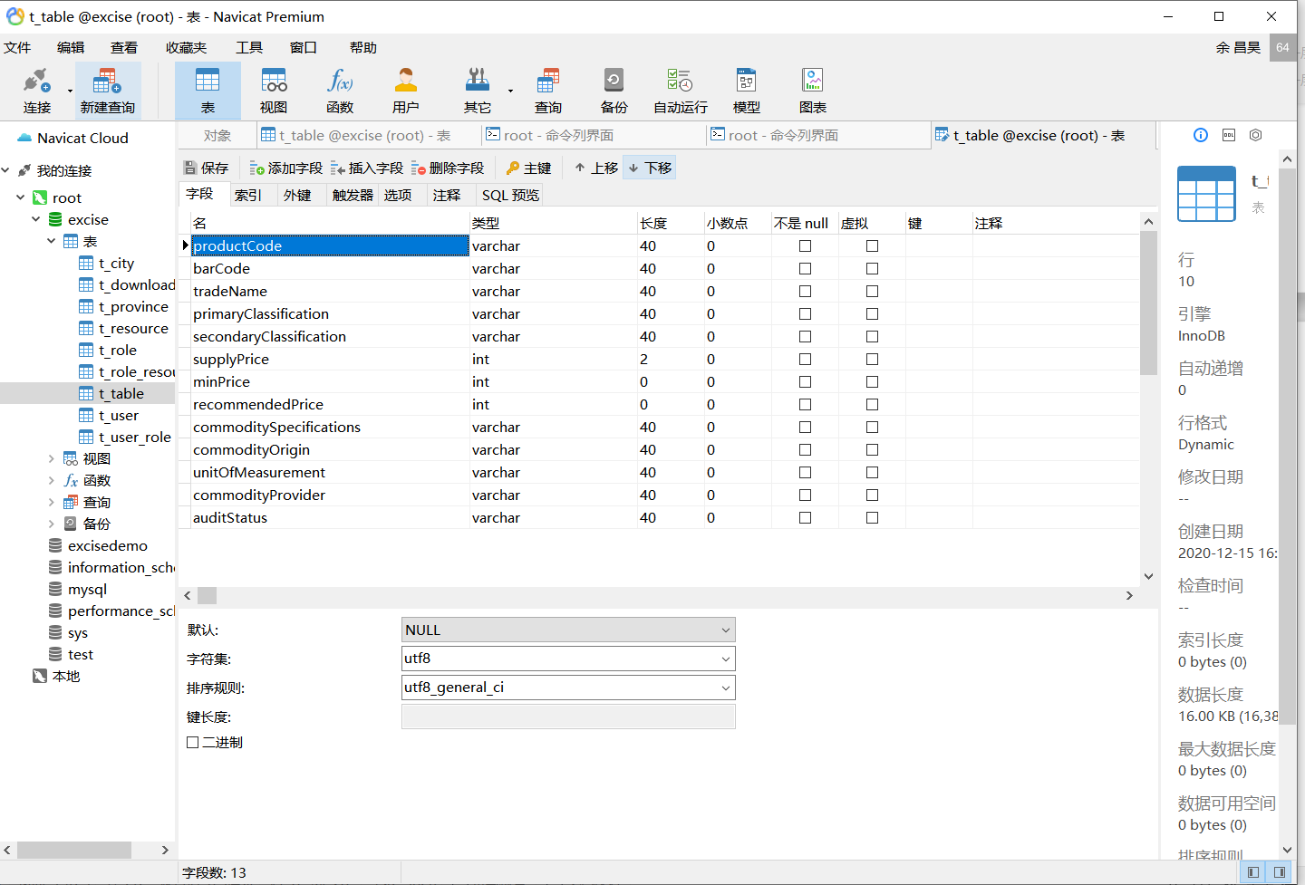

数据库ER图

## 2.2 UML类图（Class Diagram）

对于用户功能模块，共设计如下3个类。

Controller类 queryProduct :通过调用ProductDao获取符合条件的Product对象及其他数据。

VO 实体类Page:与前端传递的页面条数,起始页面,排序所需字段名与排序方式一一对应。

VO实体类Product与数据库结构进行映射的类。主要由getter,setter方法还有toString方法组成,VO类中的属性与表中的字段一一对应。

Dao类 ProductDao:主要用来对数据库进行操作,返回符合条件的Product数组与符合条件的Product个数。

各类的结构及类之间的关系如图所示：

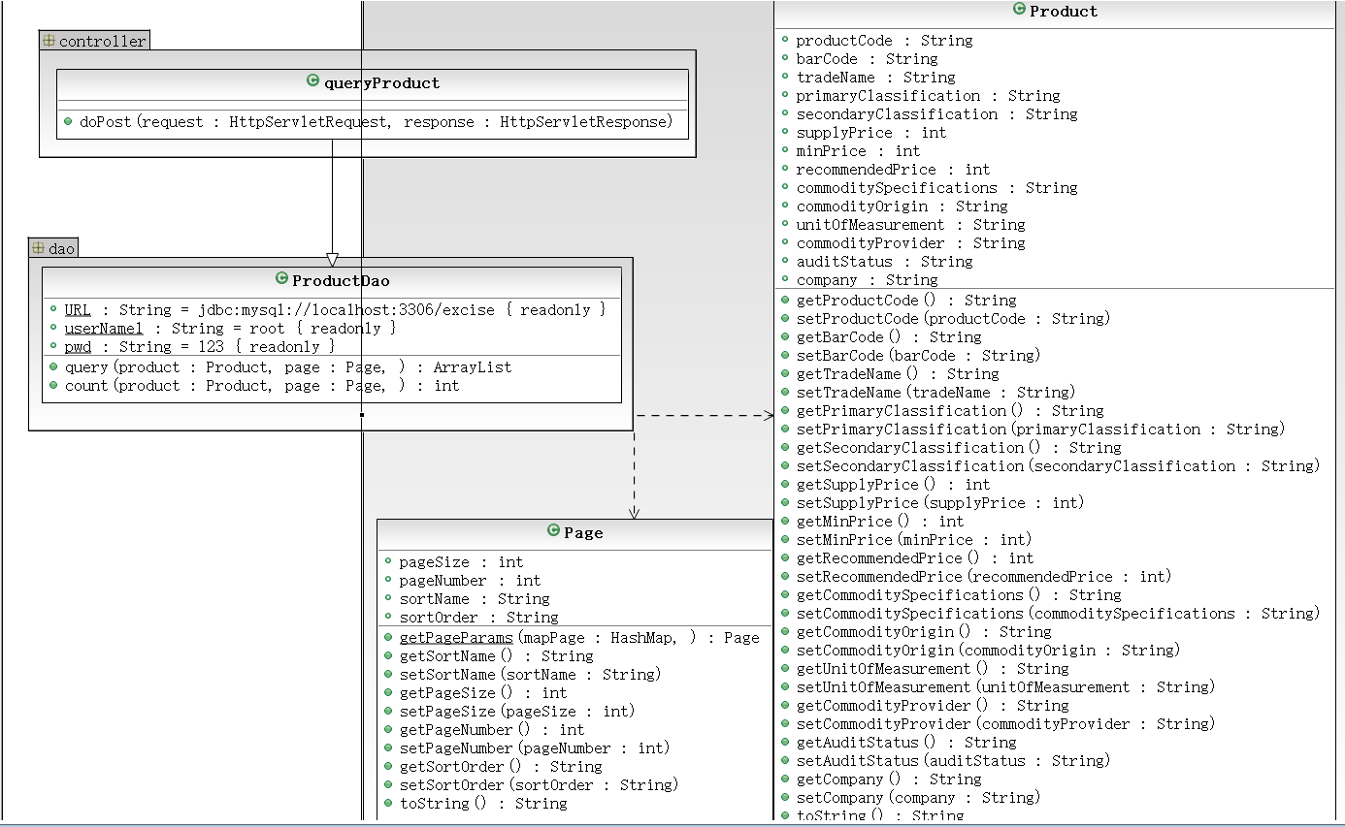

用户功能类图

## 2.3 UML时序图（Sequence Diagram）

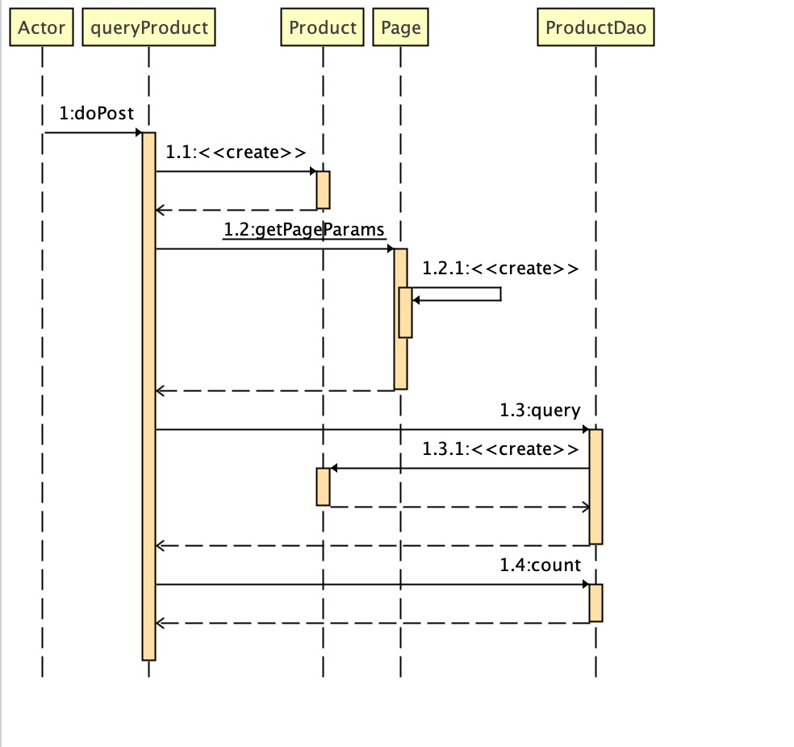

# **3 系统实现**

## 3.1 项目结构

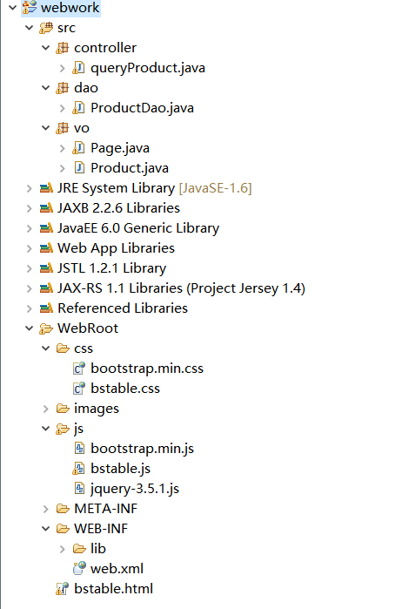

## 3.2 配置文件

### 3.2.1 web.xml文件

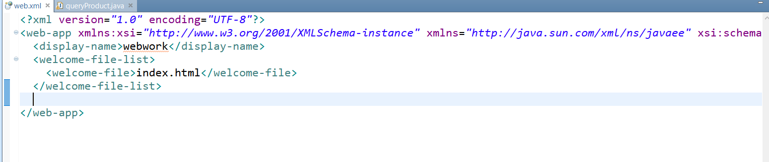

由于我习惯用注释配置路径,因此webxml文件中并没有什么东西。

3.2.2 queryProduct文件 9

3.3 VO类Page.java 10

3.3 VO类Product.java 10

3.4 DAO类ProductDAO.java 11

### 3.2.2 queryProduct 文件

@WebServlet(urlPatterns="/queryProduct.do")//通过注解实现映射

**public** **class** queryProduct **extends** HttpServlet {

**public** **void** doPost(HttpServletRequest request, HttpServletResponse response)

**throws** ServletException, IOException {

String queryParams = request.getParameter("queryParams");

String pageParams = request.getParameter("pageParams");

System.*out*.println("分页参数:"+queryParams);

System.*out*.println("查询参数:"+pageParams);

Product product = **new** Product();

ProductDao dao = **new** ProductDao();

//将json字符串参数值转换为java对象

Gson gson = **new** GsonBuilder().serializeNulls().create();

HashMap<String,Object> mapPage = gson.fromJson(pageParams,HashMap.**class**);

Page page = Page.*getPageParams*(mapPage);

**if**(queryParams!=**null**){

product = gson.fromJson(queryParams,Product.**class**);

//将查询参数转换为Product类型对象

}

ArrayList<Product>rows = dao.query(product, page);

//将查询到符合条件的Product放入数组中

**int** total = dao.count(product,page);

HashMap<String,Object>mapReturn = **new** HashMap<String,Object>();

mapReturn.put("rows", rows);

mapReturn.put("total", total);

System.*out*.println("total:"+total);

String jsonStr = gson.toJson(mapReturn);

response.setContentType("text/html;charset=utf-8");

PrintWriter out = response.getWriter();

//将结果返回到前端中

out.print(jsonStr);

out.flush();

out.close();

}

}

## 3.3 VO类Page.java

**public** **class** Page **implements** Serializable{

**private** **int** pageSize;

**private** **int** pageNumber;

**private** String sortName;

**private** String sortOrder;

**public** Page() {

**super**();

}

**public** Page(**int** pageSize, **int** pageNumber,String sortName,String sortOrder) {

**super**();

**this**.pageSize = pageSize;

**this**.pageNumber = pageNumber;

**this**.sortName = sortName;

**this**.sortOrder = sortOrder;

}

**public** **static** Page getPageParams(HashMap<String, Object> mapPage) {

**int** pageSize = Integer.*parseInt*((String) mapPage.get("pageSize"));

**int** pageNumber = Integer.*parseInt*((String) mapPage.get("pageNumber"));

String sortName = (String) mapPage.get("productCode");

String sortOrder = (String) mapPage.get("desc");

**return** **new** Page(pageSize,pageNumber,sortName,sortOrder);

}

**public** String getSortName() {

**return** sortName;

}

**public** **void** setSortName(String sortName) {

**this**.sortName = sortName;

}

**public** **int** getPageSize() {

**return** pageSize;

}

**public** **void** setPageSize(**int** pageSize) {

**this**.pageSize = pageSize;

}

**public** **int** getPageNumber() {

**return** pageNumber;

}

**public** **void** setPageNumber(**int** pageNumber) {

**this**.pageNumber = pageNumber;

}

**public** String getSortOrder() {

**return** sortOrder;

}

**public** **void** setSortOrder(String sortOrder) {

**this**.sortOrder = sortOrder;

}

**public** String toString(){

**return** "pageSize:"+**this**.pageSize+" pageNumber:"+**this**.pageNumber+" sortName:"+this.sortName+" sortOrder:"+**this**.sortOrder;

}

}

pageSize为页面条数,pageNumber为起始页面,sortName为排序所需要的字段名,sortOrder为排序的方式。

## 3.4 VO类Product.java

**public** **class** Product {

**private** String productCode;

**private** String barCode;

**private** String tradeName;

**private** String primaryClassification;

**private** String secondaryClassification;

**private** **int** supplyPrice;

**private** **int** minPrice;

**private** **int** recommendedPrice;

**private** String commoditySpecifications;

**private** String commodityOrigin;

**private** String unitOfMeasurement;

**private** String commodityProvider;

**private** String auditStatus;

**private** String company;

**public** Product() {

**super**();

}

**public** Product(String productCode, String barCode, String company) {

**super**();

**this**.productCode = productCode;

**this**.barCode = barCode;

**this**.company = company;

}

**public** Product(String productCode, String barCode, String tradeName,

String primaryClassification, String secondaryClassification,

**int** supplyPrice, **int** minPrice, **int** recommendedPrice,

String commoditySpecifications, String commodityOrigin,

String unitOfMeasurement, String commodityProvider,

String auditStatus) {

**super**();

**this**.productCode = productCode;

**this**.barCode = barCode;

**this**.tradeName = tradeName;

**this**.primaryClassification = primaryClassification;

**this**.secondaryClassification = secondaryClassification;

**this**.supplyPrice = supplyPrice;

**this**.minPrice = minPrice;

**this**.recommendedPrice = recommendedPrice;

**this**.commoditySpecifications = commoditySpecifications;

**this**.commodityOrigin = commodityOrigin;

**this**.unitOfMeasurement = unitOfMeasurement;

**this**.commodityProvider = commodityProvider;

**this**.auditStatus = auditStatus;

}

**public** Product(String productCode, String barCode, String tradeName,

String primaryClassification, String secondaryClassification,

**int** supplyPrice, **int** minPrice, **int** recommendedPrice,

String commoditySpecifications, String commodityOrigin,

String unitOfMeasurement, String commodityProvider,

String auditStatus, String company) {

**super**();

**this**.productCode = productCode;

**this**.barCode = barCode;

**this**.tradeName = tradeName;

**this**.primaryClassification = primaryClassification;

**this**.secondaryClassification = secondaryClassification;

**this**.supplyPrice = supplyPrice;

**this**.minPrice = minPrice;

**this**.recommendedPrice = recommendedPrice;

**this**.commoditySpecifications = commoditySpecifications;

**this**.commodityOrigin = commodityOrigin;

**this**.unitOfMeasurement = unitOfMeasurement;

**this**.commodityProvider = commodityProvider;

**this**.auditStatus = auditStatus;

**this**.company = company;

}

**public** String getProductCode() {

**return** productCode;

}

**public** **void** setProductCode(String productCode) {

**this**.productCode = productCode;

}

**public** String getBarCode() {

**return** barCode;

}

**public** **void** setBarCode(String barCode) {

**this**.barCode = barCode;

}

**public** String getTradeName() {

**return** tradeName;

}

**public** **void** setTradeName(String tradeName) {

**this**.tradeName = tradeName;

}

**public** String getPrimaryClassification() {

**return** primaryClassification;

}

**public** **void** setPrimaryClassification(String primaryClassification) {

**this**.primaryClassification = primaryClassification;

}

**public** String getSecondaryClassification() {

**return** secondaryClassification;

}

**public** **void** setSecondaryClassification(String secondaryClassification) {

**this**.secondaryClassification = secondaryClassification;

}

**public** **int** getSupplyPrice() {

**return** supplyPrice;

}

**public** **void** setSupplyPrice(**int** supplyPrice) {

**this**.supplyPrice = supplyPrice;

}

**public** **int** getMinPrice() {

**return** minPrice;

}

**public** **void** setMinPrice(**int** minPrice) {

**this**.minPrice = minPrice;

}

**public** **int** getRecommendedPrice() {

**return** recommendedPrice;

}

**public** **void** setRecommendedPrice(**int** recommendedPrice) {

**this**.recommendedPrice = recommendedPrice;

}

**public** String getCommoditySpecifications() {

**return** commoditySpecifications;

}

**public** **void** setCommoditySpecifications(String commoditySpecifications) {

**this**.commoditySpecifications = commoditySpecifications;

}

**public** String getCommodityOrigin() {

**return** commodityOrigin;

}

**public** **void** setCommodityOrigin(String commodityOrigin) {

**this**.commodityOrigin = commodityOrigin;

}

**public** String getUnitOfMeasurement() {

**return** unitOfMeasurement;

}

**public** **void** setUnitOfMeasurement(String unitOfMeasurement) {

**this**.unitOfMeasurement = unitOfMeasurement;

}

**public** String getCommodityProvider() {

**return** commodityProvider;

}

**public** **void** setCommodityProvider(String commodityProvider) {

**this**.commodityProvider = commodityProvider;

}

**public** String getAuditStatus() {

**return** auditStatus;

}

**public** **void** setAuditStatus(String auditStatus) {

**this**.auditStatus = auditStatus;

}

**public** String getCompany() {

**return** company;

}

**public** **void** setCompany(String company) {

**this**.company = company;

}

@Override

**public** String toString() {

**return** "Product [productCode=" + productCode + ", barCode=" + barCode

+ ", tradeName=" + tradeName + ", primaryClassification="

+ primaryClassification + ", secondaryClassification="

+ secondaryClassification + ", supplyPrice=" + supplyPrice

+ ", minPrice=" + minPrice + ", recommendedPrice="

+ recommendedPrice + ", commoditySpecifications="

+ commoditySpecifications + ", commodityOrigin="

+ commodityOrigin + ", unitOfMeasurement=" + unitOfMeasurement

+ ", commodityProvider=" + commodityProvider + ", auditStatus="

+ auditStatus + "]";

}

}

此类包含私有域,get,set方法还有toString

其中的每个域对应了数据库中的每个字段。

## 3.5 DAO类ProductDao.java

**public** **class** ProductDao {

**private** **static** **final** String *URL* = "jdbc:mysql://localhost:3306/excise";

**private** **static** **final** String *userName1* = "root";

**private** **static** **final** String *pwd* = "123";

**public** ArrayList<Product> query(Product product, Page page) {

ArrayList<Product> list = **new** ArrayList<Product>(); // 存放查询结果的集合

StringBuffer condition = **new** StringBuffer();// 查询条件

Connection con = **null**;

Statement pst = **null**;

ResultSet rs = **null**;

**if** (product.getProductCode() != **null** && !"".equals(product.getProductCode())) { // 判断是否有该查询条件

condition.append(" and productCode like '%")

.append(product.getProductCode()).append("%'");

}

**if** (product.getBarCode()+"" != **null** && !"".equals(product.getBarCode()+"")) { //

condition.append(" and barCode like '%").append(product.getBarCode())

.append("%'");

}

**if** (product.getCompany()+"" != **null** && !"".equals(product.getCompany()+"")) { //

condition.append(" and company like '%").append(product.getCompany())

.append("%'");

}//此处对应着主界面的两个输入框和选择框的模糊查询

**int** begin = page.getPageSize() * (page.getPageNumber() - 1);

String sql = "select * from t_table";

sql = sql + " where 1=1 ";

sql = sql + condition + " order by " +

page.getSortOrder() + " limit " + begin + ","

+ page.getPageSize();

//此语句是从t_table中找出符合模糊查询条件的sql语句

System.*out*.println(sql);

**try** {

Class.*forName*("com.mysql.jdbc.Driver");

con = DriverManager.*getConnection*(*URL*, *userName1*, *pwd*);

pst = (Statement) con.createStatement();

rs = pst.executeQuery(sql);

**while** (rs.next()) {

product = **new** Product(rs.getString(1), rs.getString(2),rs.getString(3),

rs.getString(4),rs.getString(5),rs.getInt(6), rs.getInt(7),rs.getInt(8),

rs.getString(9),rs.getString(10),rs.getString(11),rs.getString(12),

rs.getString(13));

list.add(product);

//将每个符合查询条件的Product存入数组中

}

} **catch** (SQLException e) {

e.printStackTrace();

} **catch** (Exception e) {

e.printStackTrace();

} **finally** {

**try** {

**if** (rs != **null**)

rs.close();

**if** (pst != **null**)

pst.close();

**if** (con != **null**)

con.close();

} **catch** (Exception e) {

e.printStackTrace();

}// 6.关闭连接

}

**return** list;

}

**public** **int** count(Product product, Page page) {

**int** num = 0;

ArrayList<Product> list = **new** ArrayList<Product>(); // 存放查询结果的集合

Connection con = **null**;

Statement pst = **null**;

ResultSet rs = **null**;

String sql = "select count(productCode) from t_table";

//此语句是从t_table中找出符合模糊查询条件的Product个数的sql语句

System.*out*.println(sql);

**try** {

Class.*forName*("com.mysql.jdbc.Driver");

con = DriverManager.*getConnection*(*URL*, *userName1*, *pwd*);

pst = (Statement) con.createStatement();

rs = pst.executeQuery(sql);

**if** (rs.next()) {

num = rs.getInt("count(productCode)");

}

//获取符合条件Product的个数

} **catch** (SQLException e) {

e.printStackTrace();

**return** 0;

} **catch** (Exception e) {

e.printStackTrace();

**return** 0;

} **finally** {

**try** {

**if** (rs != **null**)

rs.close();

**if** (pst != **null**)

pst.close();

**if** (con != **null**)

con.close();

} **catch** (Exception e) {

e.printStackTrace();

}// 6.关闭连接

}

**return** num;

}

## }

# **4 系统测试**

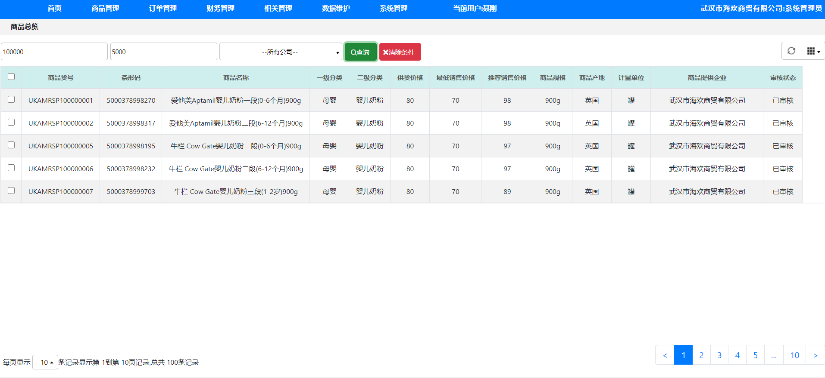

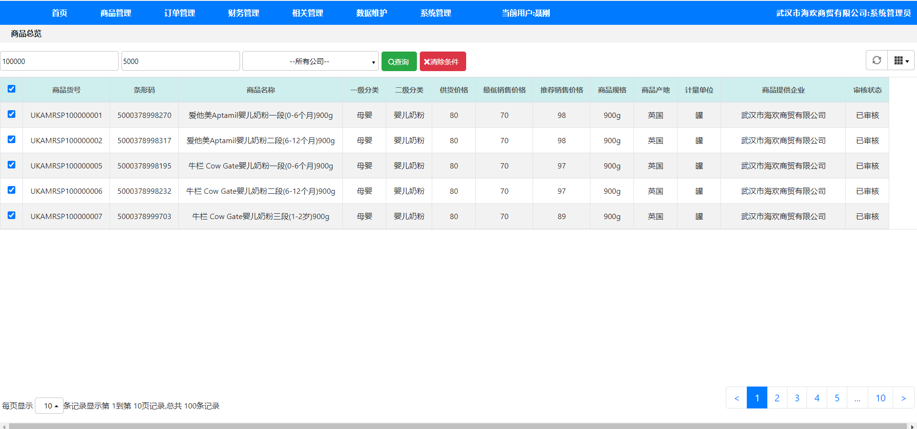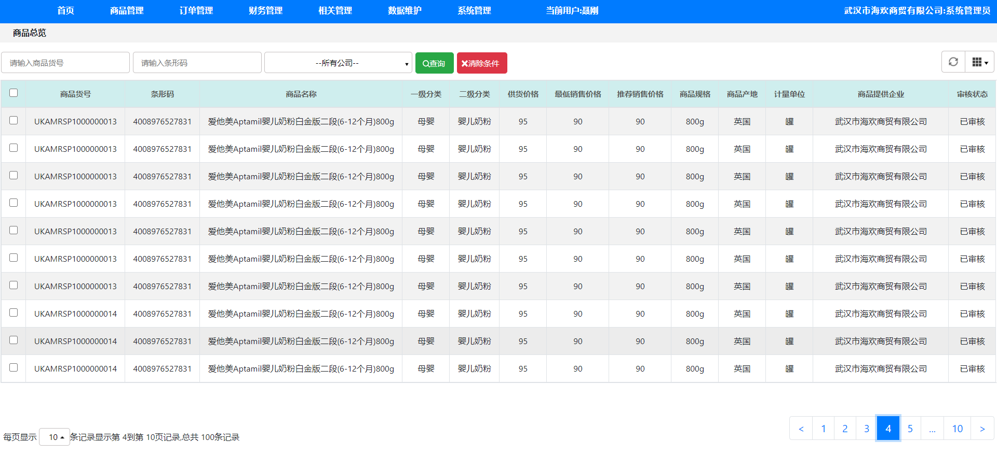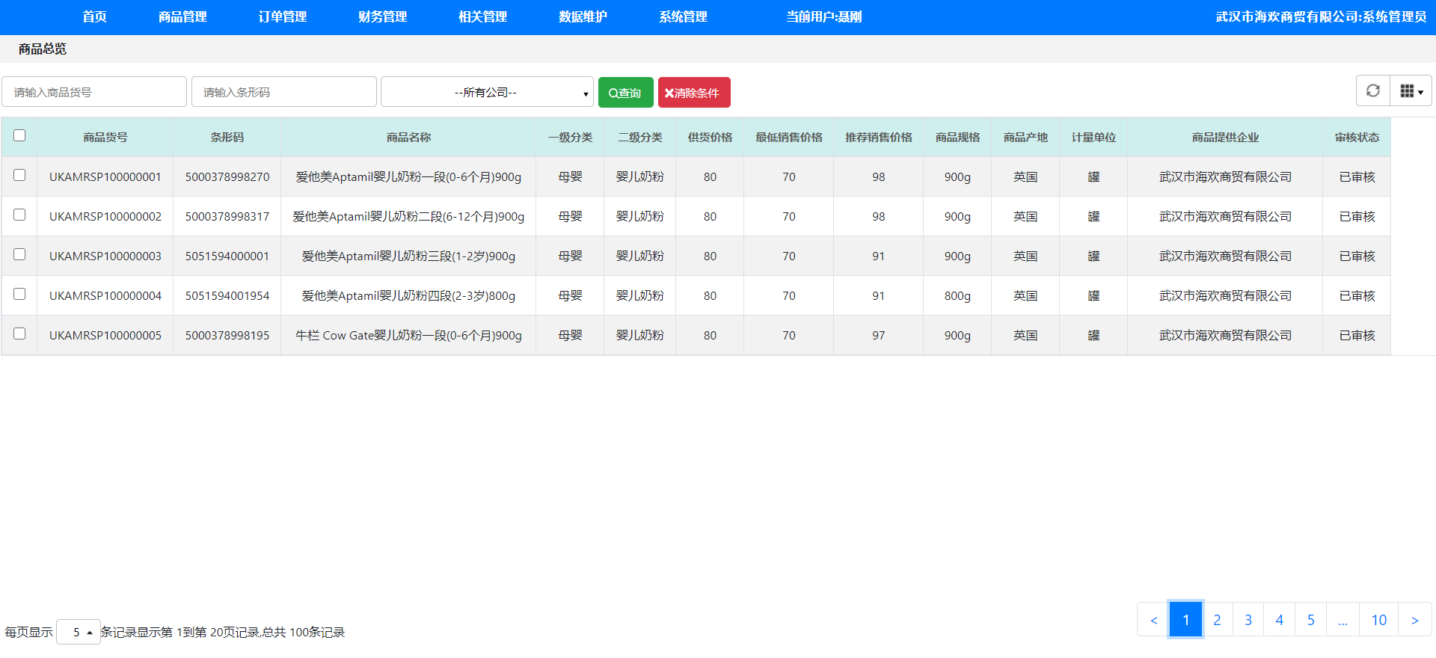

# **5 系统总结**

这次的查询产品系统虽然完成了,但是还有很多细节完成的不是很好,许多图标和按钮都是通过将元素的css中position设置为absolute,然后慢慢移动实现的,并不能动态的固定元素的位置,由于是第一次使用bootstrap框架,有几个地方并不能通过常规的css去修改样式,比如设置表格中的行高,通过height可以将他设置的更高,但是最低只能是图中那样,还有右上角那个表格排列的图标没有实现,其实这门课的收获是很多的,刚开学的时候,一点基础都没有,连html,css,js都没有听说过,开学的四次作业也是延期完成的,而且还是在借助老师的文档完成的,所有我对自己的水平并不满意,希望自己能掌握越来越多的技能,在web这条路上越走越轻松,我想前后端都学习,主要的话可能还是偏向后端，前端感觉要记的东西太多了，课程建议的话,希望老师能出一下IDEA的教程,感觉eclipse并不是很好用,满分如果是100分的话给自己打85分,还有待提高。